Workshop Web Server
(TIF330805)

LAPORAN



ACARA 19

ALEXSYS WAHYU SAPUTRA
NIM E41250598

TEKNIK INFORMATIKA KAB. NGANJUK
JURUSAN TEKNOLOGI INFORMASI
POLITEKNIK NEGERI JEMBER
TAHUN 2026

Acara 19 Postman dan API authentication
Langkah 1 — Membuat Postman Collection dengan URL Baru
- Buat Collection baru bernama "API Sistem Informasi Akademik (MVC)"
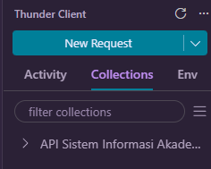
- Buat Environment "Local" dengan variabel base_url bernilai http://localhost/sistem-informasi-akademik/public (perhatikan endpoint kini tanpa akhiran .php, karena diarahkan oleh Front Controller dan Router).
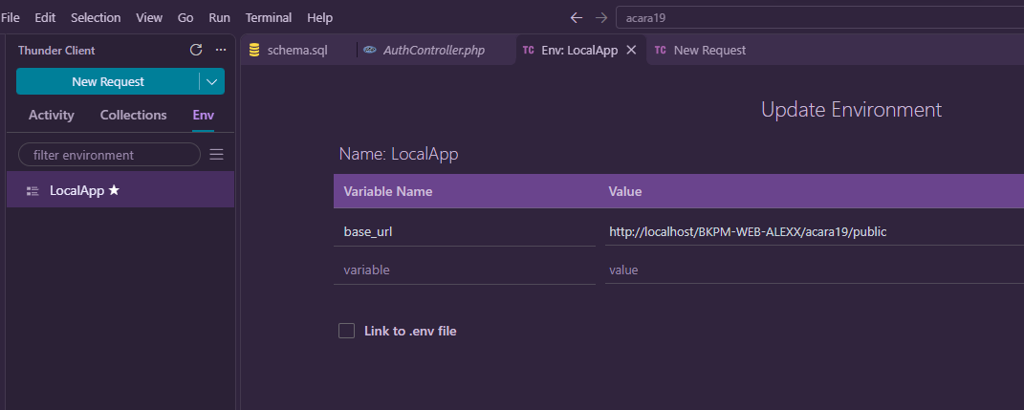
- Pindahkan request mahasiswa dari acara 17-18 ke Collection ini menggunakan {{base_url}}/mahasiswa.
- GET
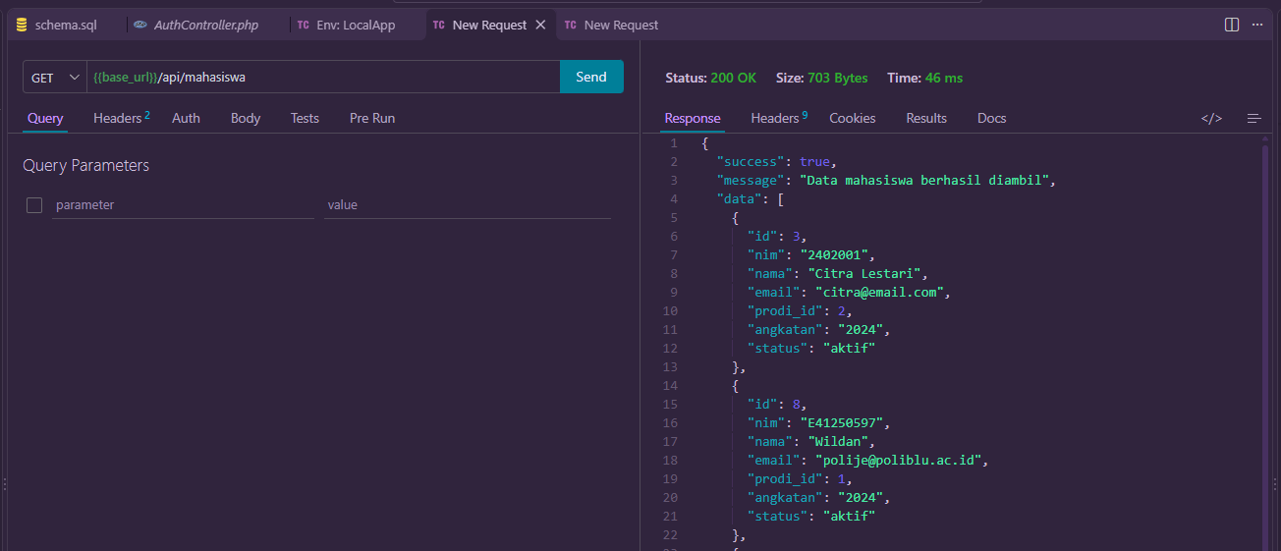
- POST
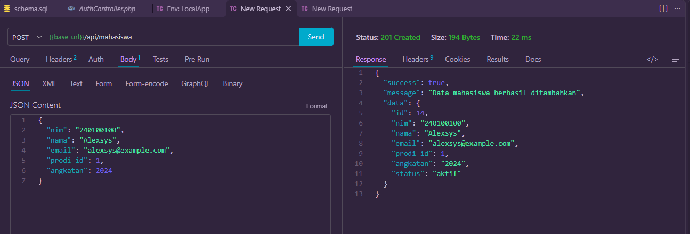
- PUT
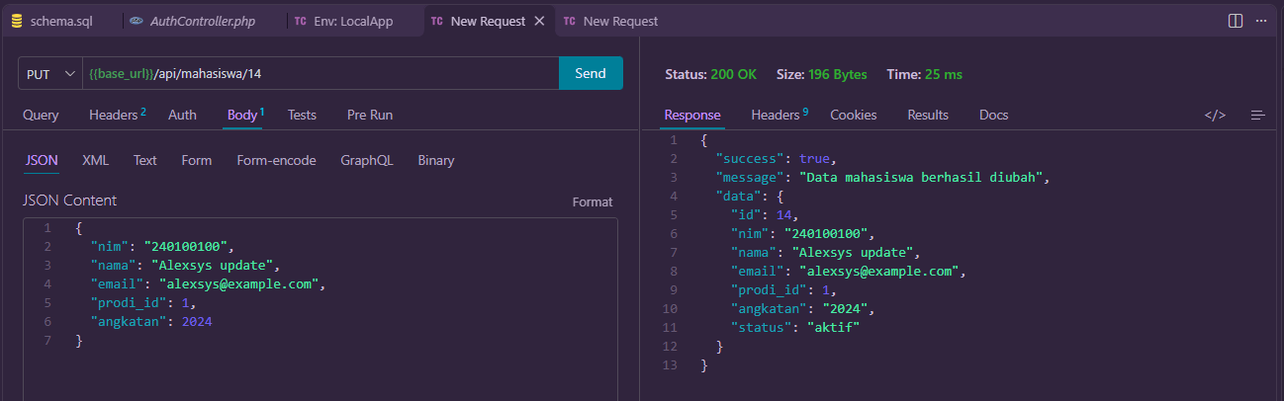
- DELETE
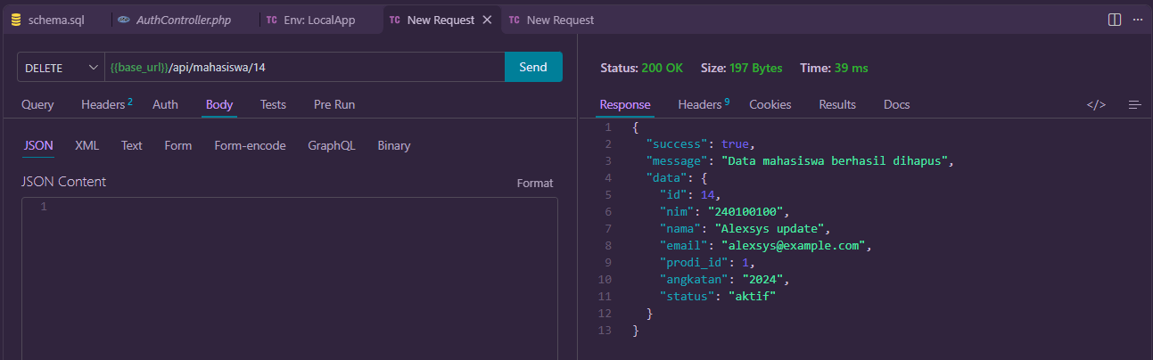
Langkah 2 — Membuat Tabel users
CREATE TABLE users ( id INT AUTO_INCREMENT PRIMARY KEY, username VARCHAR(50) NOT NULL UNIQUE, email VARCHAR(100) NOT NULL UNIQUE, password VARCHAR(255) NOT NULL, role ENUM('admin','user') DEFAULT 'user', created_at TIMESTAMP DEFAULT CURRENT_TIMESTAMP);

Langkah 3 — Membuat Model User (app/models/User.php)
<?php

namespace App\Models;

use App\Core\BaseModel;

class User extends BaseModel
{
public function create(array $data): int|false
{
$email = trim((string) ($data['email'] ?? ''));
$username = trim((string) ($data['username'] ?? ''));
$password = (string) ($data['password'] ?? '');

if ($username === '' || $email === '' || $password === '') {
return false;
}

if (filter_var($email, FILTER_VALIDATE_EMAIL) === false) {
return false;
}

$statement = $this->db->prepare(
'INSERT INTO users (username, email, password, role)
VALUES (:username, :email, :password, :role)'
);

$statement->execute([
'username' => $username,
'email' => $email,
'password' => $password,
'role' => $data['role'] ?? 'user',
]);

return (int) $this->db->lastInsertId();
}

public function findByUsername(string $username): ?array
{
$statement = $this->db->prepare('SELECT * FROM users WHERE username = :username LIMIT 1');
$statement->execute(['username' => trim($username)]);

$user = $statement->fetch();

return $user ?: null;
}

public function findByEmail(string $email): ?array
{
$statement = $this->db->prepare('SELECT * FROM users WHERE email = :email LIMIT 1');
$statement->execute(['email' => trim($email)]);

$user = $statement->fetch();

return $user ?: null;
}

public function authenticate(string $username, string $password): ?array
{
$user = $this->findByUsername($username);

if ($user === null) {
return null;
}

if (!password_verify($password, $user['password'])) {
return null;
}

return $user;
}
}

Langkah 4 — Membuat Controller AuthController
<?php

namespace App\Controllers;

use App\Core\Response;
use App\Models\User;

class AuthController
{
private User $model;

public function __construct()
{
$this->model = new User();
}

public function loginForm(): void
{
if (!empty($_SESSION['logged_in'])) {
header('Location: ' . BASE_URL . '/dashboard');
exit;
}

$flash = $this->getFlash();
$title = 'Login | SI Akademik';
$content = \VIEW_PATH . '/auth/login.php';
require \VIEW_PATH . '/layouts/main.php';
}

public function login(): void
{
$username = trim($_POST['username'] ?? '');
$password = $_POST['password'] ?? '';

$user = $this->model->authenticate($username, $password);

if ($user !== null) {
$_SESSION['user_id'] = $user['id'];
$_SESSION['user_name'] = $user['username'];
$_SESSION['logged_in'] = true;
$_SESSION['flash'] = 'Selamat datang, ' . $user['username'];

header('Location: ' . BASE_URL . '/dashboard');
exit;
}

$error = 'Username atau password salah.';
$title = 'Login | SI Akademik';
$content = \VIEW_PATH . '/auth/login.php';
require \VIEW_PATH . '/layouts/main.php';
}

public function register(): void
{
$rawInput = file_get_contents('php://input');
$data = $rawInput !== false ? json_decode($rawInput, true) : [];

if (!is_array($data)) {
$data = [];
}

$username = trim((string) ($data['username'] ?? ''));
$email = trim((string) ($data['email'] ?? ''));
$password = (string) ($data['password'] ?? '');

if ($username === '' || $email === '' || $password === '') {
Response::json(400, false, 'Username, email, dan password wajib diisi');
}

if (filter_var($email, FILTER_VALIDATE_EMAIL) === false) {
Response::json(400, false, 'Format email tidak valid');
}

if ($this->model->findByUsername($username) !== null) {
Response::json(409, false, 'Username sudah terdaftar');
}

if ($this->model->findByEmail($email) !== null) {
Response::json(409, false, 'Email sudah terdaftar');
}

$hashedPassword = password_hash($password, PASSWORD_DEFAULT);
$userId = $this->model->create([
'username' => $username,
'email' => $email,
'password' => $hashedPassword,
]);

if ($userId === false || $userId <= 0) {
Response::json(500, false, 'Registrasi gagal, silakan coba lagi');
}

Response::json(201, true, 'Registrasi berhasil', ['id' => $userId]);
}

public function logout(): void
{
$_SESSION = [];
session_destroy();
session_start();
$_SESSION['flash'] = 'Anda telah logout.';

header('Location: ' . BASE_URL . '/login');
exit;
}

private function getFlash(): ?string
{
$flash = $_SESSION['flash'] ?? null;
unset($_SESSION['flash']);
return $flash;
}
}

Langkah 5 — Mendaftarkan Resource register pada Router
if ($resource === 'register') {
if ($method !== 'POST') {
header('Allow: POST');
Response::json(405, false, 'Method tidak diizinkan untuk endpoint ini');
}
Langkah 6 — Menguji dan Mendokumentasikan pada Collection
- Tambahkan request baru POST {{base_url}}/register ke dalam Collection Postman, uji dengan beberapa data percobaan.
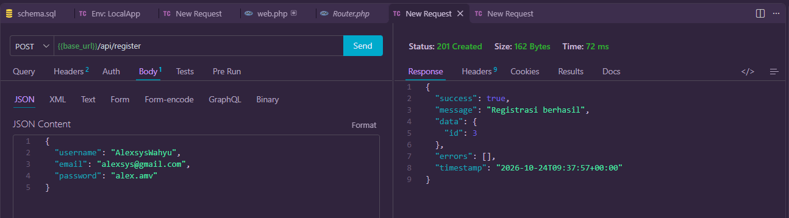
- Simpan contoh response sukses dan gagal pada masing-masing request sebagai bahan dokumentasi awal.
- Bukan Email
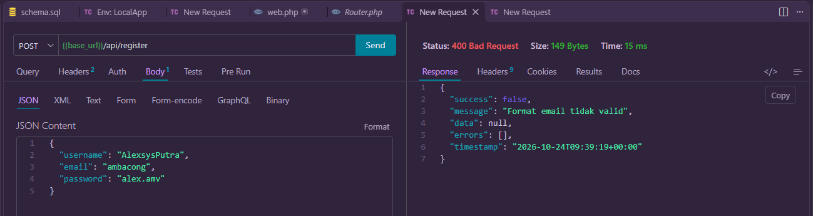
- Nama Duplikat
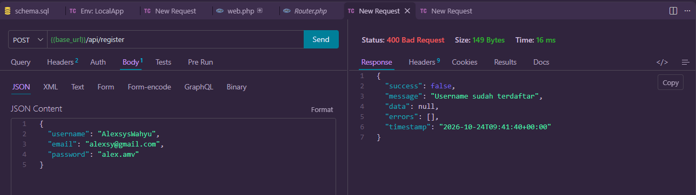

Tugas Praktik Mandiri
- Tambahkan validasi pada Model User agar email berformat valid menggunakan filter_var() dengan FILTER_VALIDATE_EMAIL sebelum data disimpan.
<?php
public function create(array $data): int|false
{
$email = trim((string) ($data['email'] ?? ''));
$username = trim((string) ($data['username'] ?? ''));
$password = (string) ($data['password'] ?? '');

if ($username === '' || $email === '' || $password === '') {
return false;
}

if (filter_var($email, FILTER_VALIDATE_EMAIL) === false) {
return false;
}

...
}

- Buat Environment kedua pada Postman untuk simulasi lingkungan staging dengan base_url berbeda.

